Drug and Alcohol Recovery Hub Drop-ins

Recovery Hubs are one – stop shops offering a full range of drug and alcohol treatment and support services. Each is run by a team of voluntary sector, NHS and social work staff.

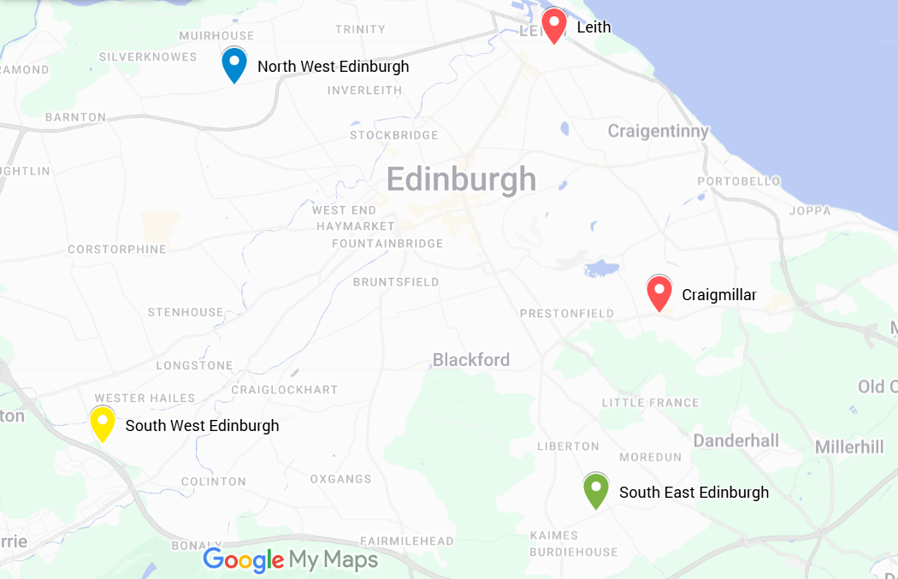
Accessing the hubs is easy. If you can, we recommend that you come to a drop-in session where the worker will listen, give advice and options including a recovery plan with you. If you agree a plan with them, they will organise the next steps.

The service is confidential. If you want to know more about how we manage privacy, please contact the hub by phone (see numbers below).

All Drop-ins are open to people who live in any area of the city. If you cannot come to any of them or you want more information before coming, please call.

We offer a choice of male or female workers wherever possible.

Hub | Drop in | Location | Monday | Tuesday | Wednesday | Thursday | Friday
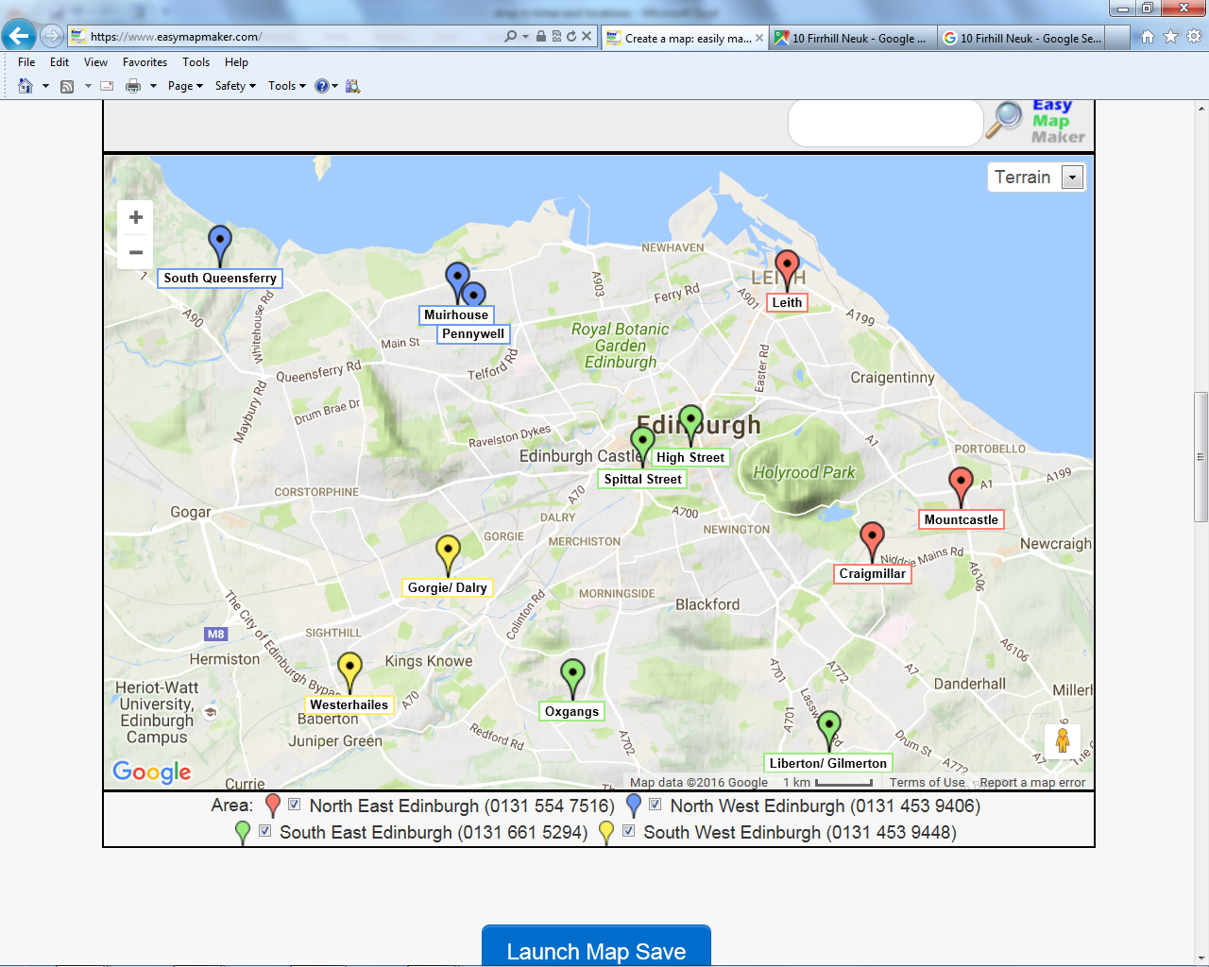North East Edinburgh  (0131 554 7516) | Leith | North East Recovery hub,  5 Links Place, EH6 7EZ  01315547516 | 1pm - 4pm | 9am -12 noon  1pm - 4pm | 1pm - 4pm | 1– 4pm | 9am -12noon
 | Craigmillar | East Neighbourhood Centre,  101 Niddrie Mains Rd, EH16 4DS |  | 1pm - 4pm
South East Edinburgh
(0131 661 5294)
 | Liberton/ Gilmerton | 13 Newtoft Street, Edinburgh, EH17 8RG  01316615294 | 1pm -3:30pm | 1pm-3:30pm | 1pm-3:30pm | 1pm-3:30pm
North West Edinburgh  (0131 332 2314) | Craigroyston Health Centre  South Queensferry Medical Practice | 18 Pennywell Road, Edinburgh, EH4 4PH  01314695044  41 The Loan, South Queensferry EH30 9HA  0131 537 4407 | 10am - 3pm | 10:00 – 12:30  13:30 – 15:00 | 10am-3pm |  | 10am-3pm
South West Edinburgh
(0131 453 9406)
 | Westerhailes | Westerhailes Healthy Living Centre, 32 Harvesters Way, EH14 3JF  01314539406 |  | 1pm-4pm | 1pm-4pm | 1pm-4pm

Other sources of support for drugs and alcohol problems
- For Information about injecting, harm reduction, Naloxone or blood borne viruses, contact the Harm Reduction Team (0131 537 8300)
- Counselling and psychological therapy services are available for people whose addiction is driven by emotional issues and which they are ready to look at. For further information, contact ELCA (alcohol, 0131 337 8188) Crew (cannabis and stimulants, 0131 220 3404) and Simpson House (0131 225 6028)
- Support for adult family and friends affected by someone else’s drug or alcohol use is offered by VOCAL Family Support addictions Service: (0131 622 6262 E-mail: fsa@vocal.org.uk
- Making contact with others in recovery from addiction can provide hope and strength. The Addiction Recovery Companion -Edinburgh app provides a full list of recovery events and meetings in Edinburgh along with information and tools to help you organise your life and keep motivated. It can be downloaded from http://arcapp.co.uk/

