

# EADP executive Meeting 4th April 2023

|  |  |
| --- | --- |
| **Present** | |
| Tony Duncan (Chair) | Service Director Strategic Planning HSCP |
| David Williams | Programme Manager EADP |
| Moira Pringle | Head of Strategic Planning Finance HSCP |
| Neil Whiteside |  |
| Adele Hill | SUNE |
| Victoria Kerr | Sector Manager (Acting) Communities and Families |
| Steven McCann | Scottish Prison Service, HMP Edinburgh |
| Angela Dixon | REAS |
| Patricia Burns | Locality Manager, Substance use and Mental health, EH&SCP |
| Rose Howley | Chief Social Work Officer |

|  |  |
| --- | --- |
| **In Attendance** | |
| Jim Sherval | Specialist in Public Health. NHSL |
| Samantha Ainslie | Police Scotland |
| Deborah Clark |  |
| Carey Fuller | Acting Senior Manager, Criminal Justice |
| Flora Ogilvie |  |
| Carys Moodie | Business Development Officer EADP |
| Lorna Watt | Change and Delivery Officer EADP |
| Neil Stewart | Planning and Commissioning Officer EADP |

|  |  |
| --- | --- |
| **Apologies** | |
| Judith Proctor |  |
| Shirley McLaren | Community Safety |
| David Abernathy | HMPE |
| Angela Voulgari | Safe and together |
| John Ferrer | CEC/ S&SC |

Minutes of previous meeting (Nov 2022) and actions arising (paper 1)

Agreed as an accurate record.

One action not covered on the agenda of this meeting:

“**3(B) Public health: responding to the Licensing Board consultation –** NHSL PH to make an initial submission”. DW to seek update from Public Health

Summary of developments 2022, outline action plan 2023 (DW)

David gave summary of key developments from 2022 and outlined some knew requirements for 2023.

|  |  |
| --- | --- |
| Highlight actions in 2022 | Highlight Plans for 2023 |
| * MAT standards and treatment expansion plan * LEAP/Ritson expansion * Non-recurring spending plans ++ * Governance and reporting changes – SG and local * C&PT tendering * YP collaborative * Governance self-evaluation * DTTO closure * DRD figures (2021) | * MAT submission (April) * MAT plan for Criminal Justice Settings (prison, court, police custody) * Alcohol Harms group action plan * Lived and living experience panel * CAPSU commissioning * MICU commissioning * DCR and Drug Checking reports * Waiting times and DAISy * Governance review action plan |

**Action:** DW to provide timeline of the actions over 2023 for the next meeting

|  |
| --- |
| Police Scotland local plan (paper 2: <https://bit.ly/3sTcP3d>) |

Neill Whiteside presented the draft Edinburgh Policing plan for 2023-26. Currently it is week 11 of a 12 week consultation process. Online and video information on the process is available. The Edinburgh and other local plans will be laid before Scottish Parliament in April.

The “plan on a page” is:

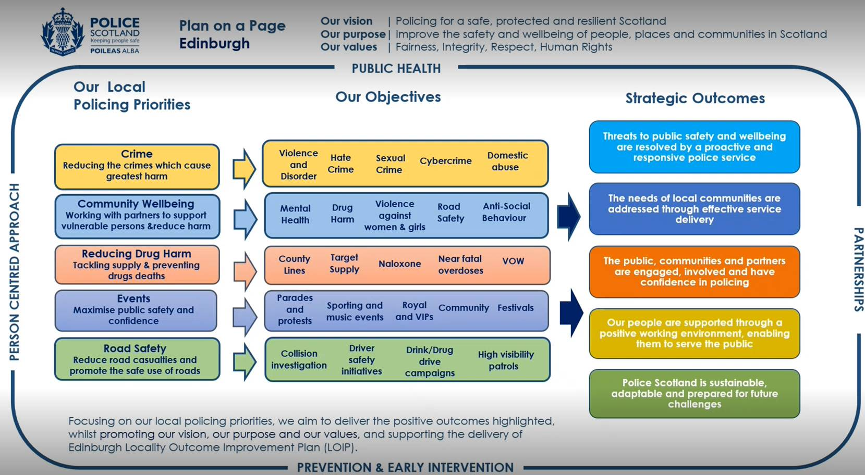

The very high level of partnership work overlapping with the ADP’s priorities was noted by several members and it was generally commended. The level of priority given to drugs and (to a lesser extent) alcohol

**Queries/ Comments from the group included:**

* How is prevention represented in the plan’s outcomes? Edinburgh has a unit (PIP – prevention, interventions, and Partnerships) which works on designing out crime opportunities and taking a trauma informed, LOIP-focused, cycle-breaking public health-based approach. This joint work complements the traditional enforcement role.
* Not clear from the single page that the MVAG work is being fully captured. As a prospective plan, future harm reduction innovations might need to be captured (DCR, drug testing and linking into treatment following police custody etc). Neill to consider whether they are fully enough represented and consult with David and others if more is needed in the planning.
* Preventing child exploitation not captured in the plan-on-a-page but Neill to verify that it is fully identified in the main plan.
* Alcohol possibly less strongly represented – policing of the night time economy and involvement in the licensing board’s decisions. EADP strategy includes reducing availability of alcohol and that public health priority could be represented. Neill welcome to meet PH/ EADP re this if that would be helpful.

Services for Children Affected by parental substance use (paper 3)

As per the paper – currently the ADP C&F jointly fund and commission CAPSU services through a contract which is due for review and recommissioning. The plan is to review the provision (ADP to lead) and recommission in the light of multiple changes to funding and guidance and strategy (in A&D and C&F).

Funding availability has, however, changed: C&F have reduced their expected revenue contribution – they are able to offer revenue, but reducing the level of funding by 66k (matching EADP contribution). To accommodate this reduction for Oct 23- Mar 24, the ADP is asked for 33k additional funding as well as agreement to the overall plan.

**Points raised:**

* It was clarified that the waiver cannot be authorised through the ADP – the request here is for funding and the council will be asked to extend the contract. This use of a waiver is recommended by CEC procurement.
* The group is reluctant to agree the principle of adding to our funding contribution as others falls. However, it was noted that the availability of other possible funding is expected to be good and that the risks entailed in stopping the services are not acceptable.
* The other aspects of the paper (plans for development etc.) were agreed.

**Actions:**

* Paper to be urgently re-drafted to reflect the importance of sustaining the service more strongly in the short term and to highlight the risks implied by C&F’s decision (NS/ DW).
* The group made an agreement in principle to allocate the money subject to the re-drafted paper being agreed electronically.
* The group wish to raise the concerns about this decision with Children and Families: EADP officers to draft letter for Tony/ Judith to convey to C&F.

Accommodation and out of hours care for LEAP (paper 4)

Clarified that we do not anticipate a change in the model or location of the care, but a change of the finance and contracting arrangements over the course of the year

**Actions:** Recommendations accepted. Update requested for June Executive meeting.

Finance update (paper 5)

Eleanora (H&SCP finance) described a tabled paper, replacing the first half of paper 5 and summarising the finance up to q3 of 2022-23.

* EADP have not drawn down 2.3m of the funding allocated to the ADP from the SG but can probably draw it down if we need to
* EADP still have c£1m unallocated non-recurring funding AND we will generate more in this and future years – even with the clawback there is still money to expand and improve services
* EADP have £350k unallocated revenue but at this point don’t want to commit most of that permanently

**Actions:**

* Paper noted
* Risk noted that the SG may not permit ADPs to retain the allocation – the SG letter indicates but does not explicitly state that it remains available to the ADP. Any very substantial allocation of the funding will need SG confirmation.

Non-recurring spending plans (DW) paper 5

**Actions:**

* All circulated spending proposals approved
* Two additional proposals (Intermediate Care and Addiction workers’ training programme) tabled and agreed
* Consequent spending plan therefore

|  |  |  |  |  |  |  |  |
| --- | --- | --- | --- | --- | --- | --- | --- |
| **Code** | **Title** | **Summary** | **Cost (pa and total)** | **Source** | **Organisation** | **Lead** | **Notes** |
| **Feb-23-01** | Contribution to Street Begging Strategic Co-Ordinator  (Appendix 1a) | EADP contribution (1/3 of the cost) of a lead for a strategic planning post based in “Place” | 10k pa for 2 years 20k total | General underspend | NHSL CP | David Smith | Agreed as per paper |
| **Feb-23-02** | Feasibility study for drug Checking services  (Appendix 1b) | Additional research and needs assessment work alongside the previously agreed DCR study in line with elected member request | <£10k, one off, to be negotiated with providers | General underspend | EADP | David Williams | Agreed as per paper |
| **Feb-23-03** | Additional capacity in the EnCompass programme to expand alongside the LEAP programme  (Appendix 1c) | An increase in the capacity of the Encompass programme proportionate to respond to the increasing number of patients attending the LEAP programme | £6k pa for 3 years - £18k total | Residential Rehab underspend | Access to Industry | David Williams | Agreed as per paper. Adele noted conflict of interest. |
| **Feb-23-04** | Accommodation and out of hours support for LEAP | contributing funding for the proposed accommodation and the support service required | <£215k in 2023-24, though anticipated to be substantially lower | Residential Rehab underspend + 23/24 allocation | EADP | David Williams | Agreed as per paper |
| **Feb-23-05** | CREW Expansion of Harm reduction interventions for young people | Deliver services to reduce harm to young people in Edinburgh from risky or damaging use of drugs including alcohol through advice, information and support. | £49k pa for 2 years (£98k total) | WFA underspend | CREW | Neil Stewart | Agreed as per paper |
| **Feb-23-06** | Intermediate Care | ADP contribution of 50k to the overall cost of intermediate care | £50k pa for 5 years (£250k total) | General underspend | Waverly Care et al | David Williams | Tabled - Any queries to DW  Agreed in principle – other aspects of the plan require confirmation of IJB EMT. if the cost changes the request will have to come back to the EADP exec. |
| **Feb-23-07** | Addiction Workers Training Programme | Train 4 people with lived experience of Drug and Alcohol use and recovery to SVQ 3 level in Health and Social care (match funding SG contribution – they will fund 2 if we fund 2) | £46k | General underspend | SDF | David Williams | Tabled - Any queries to DW |

Residential Rehab pathway (Paper 6)

As per paper, significant delays have developed in the pathway to residential rehab in Edinburgh and the number of people accessing this treatment has fallen. Recently there has been progress on reducing this delay and the recommendations (requesting continuous reporting on this area of work and additional data) are intended to provide the Exec. with assurance that the performance is sustainably improved.

**Actions:** recommendations agreed

DTTO (Carey Fuller)

Carey gave an overview of the current situation of the DTTO:

* Service closed to new patients owing to loss first of medical and subsequently of nursing staff. It is expected to re-open (thanks to NHS assurances re the staffing) on the 27th February.
* In light of the complexity of the provision (it is run partly by NHS staff but funded and managed in CJ; there is a national review of DTTO also ongoing; the service works across Edinburgh and M&E Lothian) it is undergoing a standalone review, potentially involving Healthcare Improvement Scotland.
* Additional risk involved: Seeking premise for the service as current accommodation not suitable.

Progress with involvement of lived/ living experience

Lorna outlined some key developments:

* Lived and living experience panel: ongoing recruitment (interviews tomorrow) of a development lead for a strategic reference group of people with lived and living experience
* Providers’ forum
* Peer research  - this is an element of the MAT standards implementation and reporting. 37 interviews undertaken with users of services, 4 with carers and focus groups with practitioners. Very high level of activity relative to other areas ofthe country.

It was noted that this area is now progressing effectively, and this was welcomed.

**Action:** Lorna to share description of the process and outcomes to Tony as a contribution to the IJBs wider consultation and co-production work.

MAT standards:

Most recent report (October – Dec) indicated that 3 of the 5 standards were green and two red (RAG assessment)

* MAT 1 & 2 – red
* MAT 3, 4 & 5 – green

Since Dec: plan for skeletal MAT 1 service has been put in place:

Interim plan: a nurse from a hub has been recruited. SOP in place, 3rd sector in place

Permanent recruitment: nursing posts close tomorrow. Other posts in recruitment pipeline

We are currently gathering data for the final submission and projected grades are estimated to be:

* MAT 1 red/ amber
* MAT 2 Amber/ green
* MAT 3, 4 & 5: Green

Positive progress noted by the group.

DCR update:

Two key points

* Very well qualified group appointed to complete this feasibility study
* As per appendix of paper 5, an additional element is being added to the study – drug testing feasibility research
* Recommendations accepted

AOCB: None

**DONM: 4th April 3-5pm**