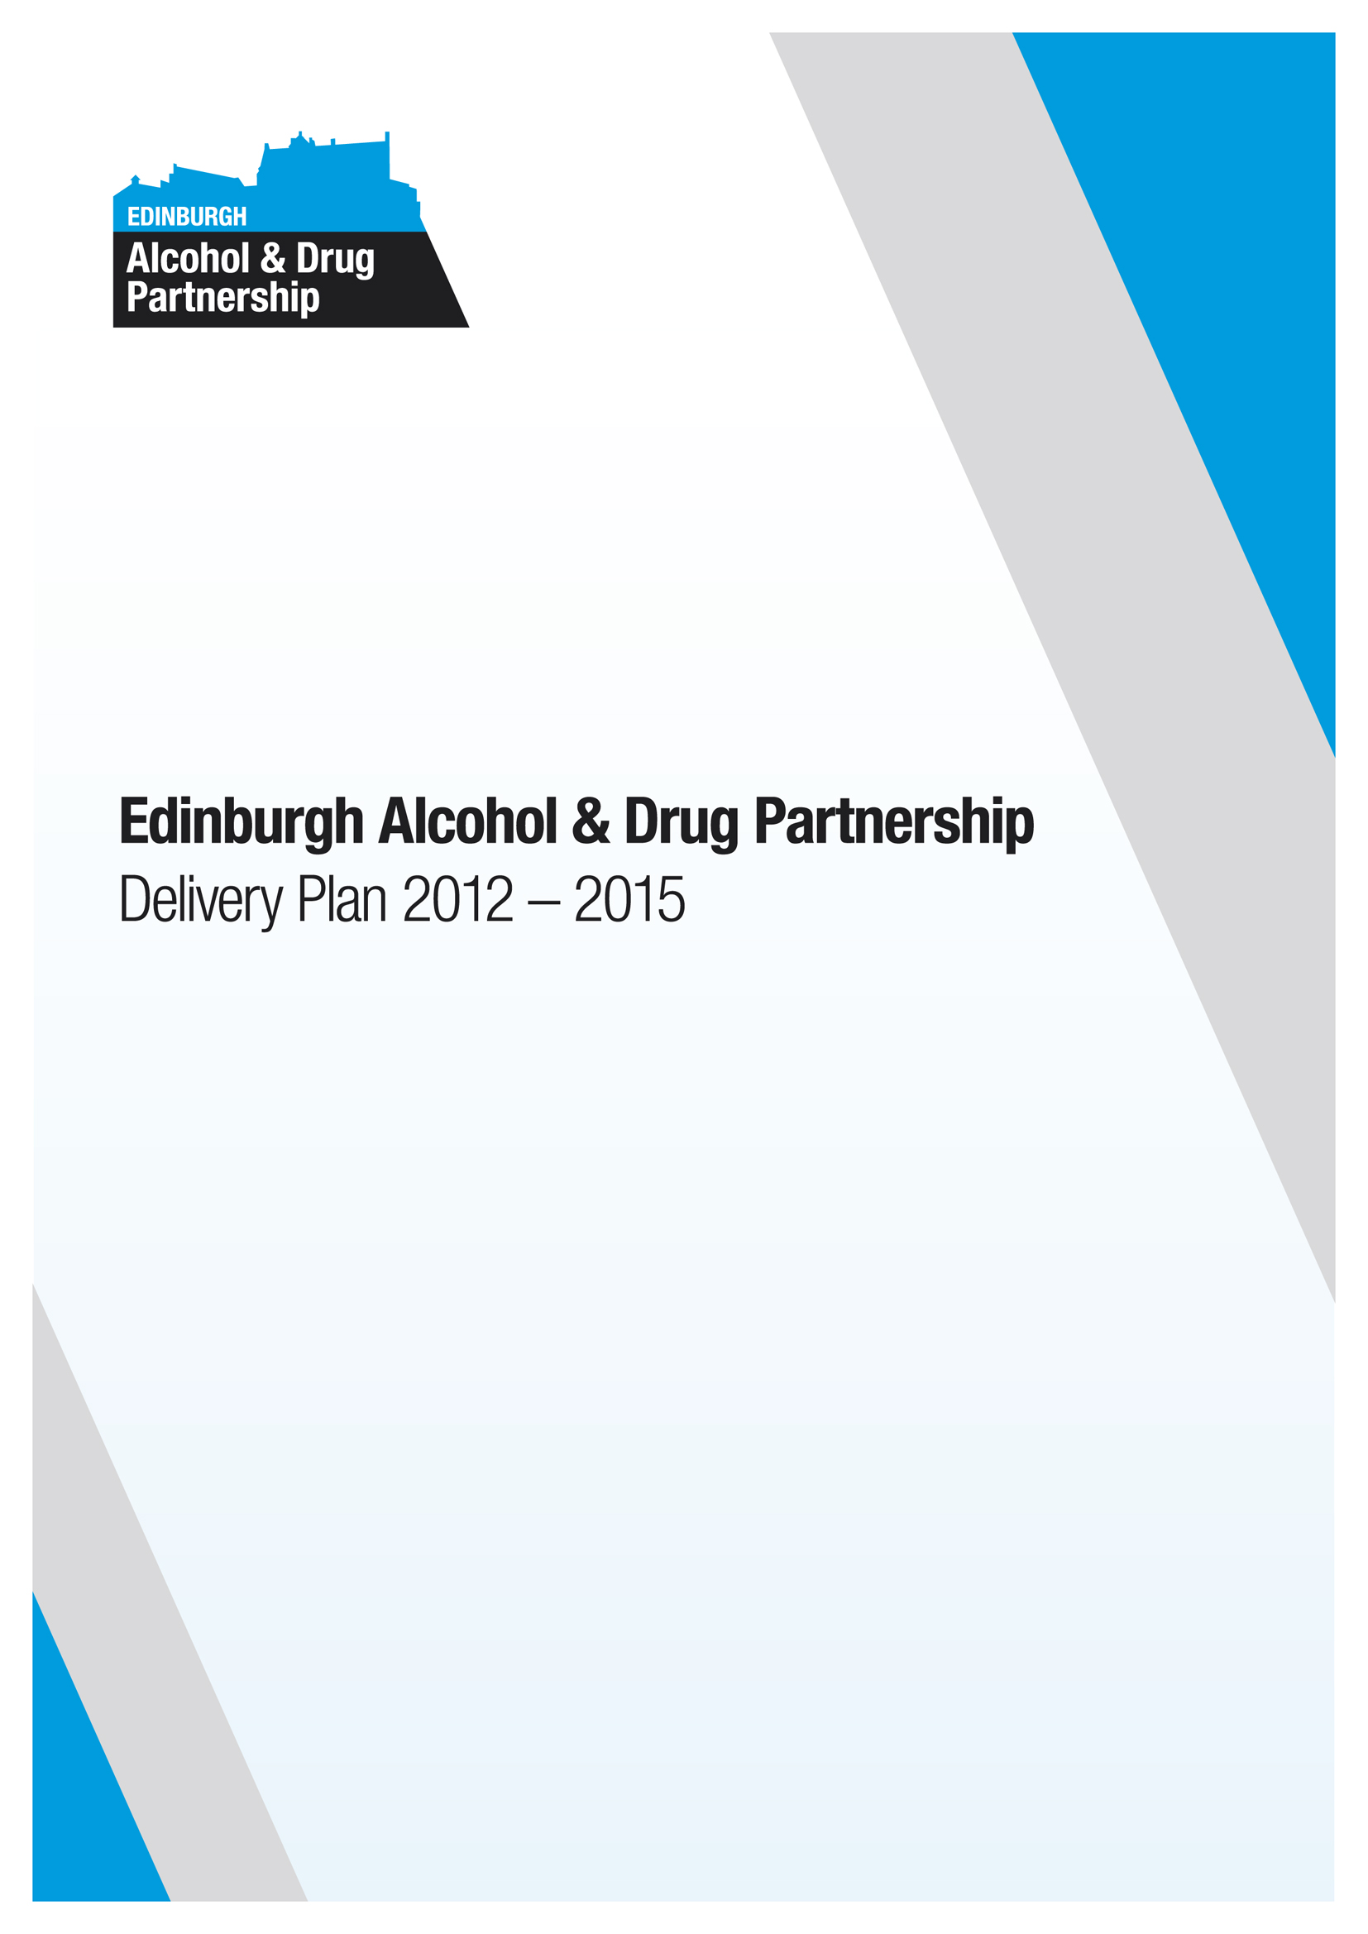

Annual Report 2015/16

Document Details:

Edinburgh Alcohol and Drug Partnership – Annual Report 2015/16

Contents

- Background Page 2

- Introduction Page 3

- Summary of Progress 2015/16 Page 4

- Financial Framework Page 15

Appendix 1: Progress against Ministerial priorities Page 18

Appendix 2: Additional Information Page 26
      - Background
The Scottish Government requires that Alcohol and Drug Partnerships complete an annual report on progress. This report sets out the key requirements of the Scottish Government and includes other information where this helps to set out the Edinburgh Alcohol and Drug Partnership’s progress.

Alcohol and Drug Partnerships were established in 2009 as the vehicle for planning and developing responses to drug/alcohol problems at a local level. Edinburgh Alcohol and Drug Partnership is has membership from the following organisations:
- The Third Sector in Edinburgh
- NHS Lothian
- The City of Edinburgh Council
- Police Scotland
- Scottish Prison Service (HMP Edinburgh)

The partnership is chaired by Michelle Miller, Chief Social Work Officer, City of Edinburgh Council.

Edinburgh Alcohol and Drug Partnership is accountable to the Edinburgh Partnership. For further information about the Partnership please see www.edinburghadp.org.uk.

Partnership Details

EADP Chair | Michelle Miller
Contact: | Nicholas Smith
Contact telephone | 0131 529 2117
Email: | Nicholas.smith@edinburgh.gov.uk
Date of Completion: | 12th September 2016
Date published on ADP website | 30th September 2016

The content of this template has been agreed as accurate by the Alcohol and Drug Partnership, and will be shared with our Community Planning Partnership at its meeting on 10 September 2015.
      - Introduction
EADP has a clear vision for Edinburgh as:
A city which has and promotes a healthy and responsible
attitude to alcohol and where whole family recovery from problem alcohol and drug use is a reality.

This vision is supported by three high level outcomes which are used to plan and deliver this strategy:
- Children and young people’s health and wellbeing are not damaged by alcohol and drugs

- Fewer people develop problem drug/alcohol use and more people (and their families) are in recovery

- Individuals affected by alcohol and drugs are safer and communities are stronger

This report sets out our progress on delivering against these three high level outcomes. It also includes our progress on delivering on national priorities set at a ministerial level within the Scottish Government.

      - Summary of Progress in 2015/16

This section of the report summarises the partnership’s progress in 2015/16. It is important to note that this section of the report is a summary and does not attempt to set out all achievements and progress in 2015/16

Outcome 1: Children and young people’s health and wellbeing are not damaged by alcohol and drugs
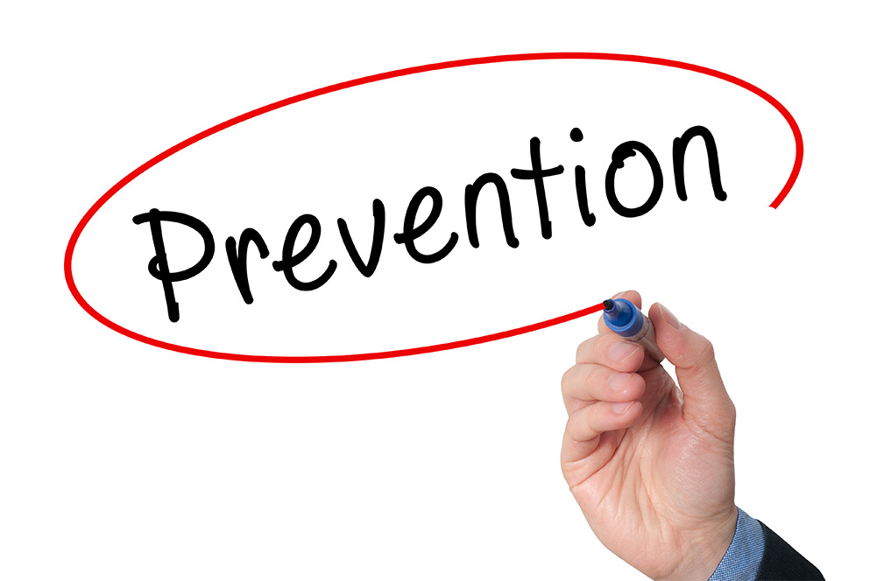
Alcohol / Drug Education and Prevention
Children and Families and Youth Work staff have received training in delivering Alcohol Brief Interventions (ABIs) in the city. It is reported that in 2015/16, over 256 ABIs were delivered across the city; the actual number is likely to be significantly higher as not all ABIs are reported through data collection systems.
Alongside this, education and prevention programmes are delivered across the curriculum in school settings. This includes:
- Queen Margaret University, Meet The Alcolols Project
- Alcohol Focus Scotland, Alcohol Marketing Education
- The Junction, HOT and Crew programmes of drug/alcohol education

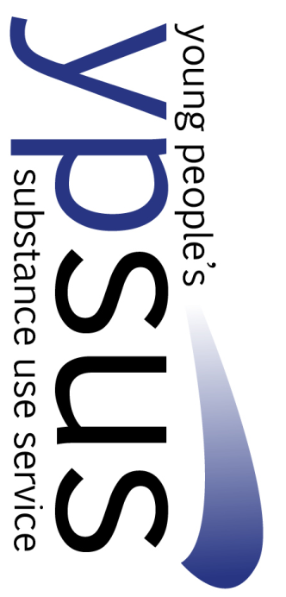
Responding to Young People’s Alcohol and Drug Use
The Young People’s Substance Use Service (YPSUS) was established in September 2015 as a partnership response to drug and alcohol problems amongst young people. The service brings together the following pre-existing services:
- Crew - Third Sector
- Castle Project - Third Sector
- Health Opportunities Team - Third Sector
- The Junction - Third Sector
- The Adolescent Substance Use service (ASUS) - NHS Lothian
- Young People’s Service - City of Edinburgh Council
These organisations work together to offer a consistent and effective response to alcohol and drug problems amongst young people across the city. Within YPSUS the third sector services offer preventative, one-to-one services for young people developing problems around alcohol and drug use within the communities which they serve. In stances where a young person’s alcohol and drug use of significant concern there are arrangements in place for swift access to medical and other services through the Young People’s Nurse at ASUS and the Young people’s Service.
There is a consistent approach in terms of assessment and referral forms, ways of working and outcome monitoring.


Services for Families Affected by Parental alcohol and Drug Use
It is estimated that approximately 7,000 children in Edinburgh live with parents with at least some level of problematic alcohol use and 2,173 children affected by problem drug use. The criteria used are wide and many of these children will not be at high risk of harm.
EADP commissions specific services for families and children affected by parental substance. In 2015, there key partners came together with parents to redesign these services. The new service has two priority areas.
- Support for parents to improve their parenting as a part of their recovery.
- Support for children and young people who extra help when their parents move into recovery.
These services were put to tender during the early part of 2016 and a coalition of Circle and Cross Reach (Sunflower Garden) was awarded the contract. The new service commenced on 1 April 2016.

Success Measures
The table below summarises the key data used to identify the success within this stand of the strategy.

Measures | Baseline  2014/15 | Target | Progress  2015/16 | Comment / Source
Fewer children and young people using drugs; children and young people choosing to drink alcohol start later in life and take fewer risks
- % of 15 year olds drinking once a week or more | 14% | 10%  (2018) |  | Performance is measured every 4 years; Source: National SALSUS Survey 2018
- % of 15 year olds who have used drugs in previous month | 9% | 7%  (2018)
The impact of parental alcohol and drug use on children and young people is reduced
- Number of ABIs delivered in maternity settings | 300 | 336 | 550 | Source: Lothian ABI Annual Report
- Measure of family recovery (Benchmarked within new service from 2016/17) | Baseline and targets available in 2016/17 |  |  | Data to be collated from April 2016
Children and young people receive appropriate and timely support for alcohol and drug problems
- Number of children and young people in receipt of specialist support | 136 | 150 | Data not available 15/16 | Source: Young People’s Substance Use Service

Outcome 2: Fewer people develop problem drug/alcohol use and more people (and their families) are in recovery

Service User Involvement and Peer Support
Edinburgh ADP has a framework for developing service user involvement called Hear Our Voice. This sets out three areas for focus:
- Individual
This is where people are involved in research, questionnaires, focus groups to support service development.
During the course of 2015, all alcohol and drug treatment providers completed a quality assurance benchmarking process; this included standards around individual service user involvement.
Examples of effective practice in 2015/16 include:
  - You said, we did 2015-2016: Services continued to use anonymous suggestions boxes and “you said, we did” posters. After clients used the feedback system, services altered opening times, revised staff training, used text reminders to prompt clients about appointments and, after concern was raised about possible dealing near the premises, the service raised awareness of their use of CCTV and possible police involvement and no further concerns were raised. They also received a great deal of positive reinforcement about service.
  - Arc App was developed in close consultation with the recovery community and service users and their input, over a number of consultations, changed the functions included and the “look and feel”. They make an ongoing contribution to the content of the app.
  - VOCAL’s Family Support Addiction service facilitated carer engagement to influence the shape of services both through participation in a conversation cafe dedicated to looking at their needs and by presenting to groups of managers. These were powerful interventions highlighting significant unmet need. The awareness raised has resulted in additional staff training and in measurable commitments to better practice in relation to supporting and involving carers.
- Grassroots
This is where people meet regularly and either seek to influence service delivery or develop their own responses to problems.
In 2015/16, Edinburgh saw the emergence of three new recovery movements across the city:
  - Dry Dock (Leith)
  - Branching Out in Recovery (Carigmillar)
  - Solace Cafe (Gorgie)
These movements came together in February 2016 alongside the Serenity Cafe and key fellowships (AA, NA, CA, Smart Recovery) to establish the Recovery Collective. The Collective meets monthly to share learning and support the development of recovery groups across the city.

Alongside this, an App has been developed, ARC-E Edinburgh, which maps all self help groups across the city. The App relies on the recovery community to upload information on activities.

- Wider horizons
This is where people are working together with policy makers at key planning groups and decision making forums.
Members of the Treatment and Recovery Collaborative have supported the development of the Recovery Collective. The Collective is considering its role in influencing the planning and development of treatment and recovery services in the city.
Alongside this, guidance and protocols have been developed to support the recruitment of volunteer and paid peers within treatment and recovery services.

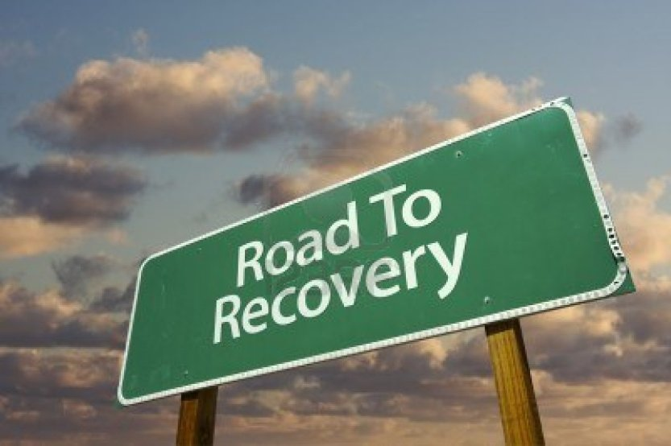
Redesigning drug/alcohol treatment and recovery services
National prevalence data suggests that there are approximately 6,600 people with problem drug use in Edinburgh. Local service data suggests that there are 3,500 people in primary care and specialist treatment services at any given time, giving a service take up ratio of 53%. These services provide medical treatment, one-one support, group work, counselling and connection with recovery groups and the recovery community.

During 2015/16, there was a major redesign of these services shifting towards a more recovery oriented approach and increasing capacity within services. This has resulted in the following changes:
  - Key working arrangements managed by the third sector
  - The development of a programme of activities for people who have achieved stability and are ready to move on in their recovery
  - A clear role for people with lived experience within treatment services
Services were redesigned and a tender exercise completed by December 2015. New contracts were awarded to Lifeline, Turning Point, Edinburgh and Lothian Council on Alcohol (ELCA) and Vocal from 1 April 2016.

Families and carers
Family members can play a significant role in supporting people’s recovery from problem substance misuse. However, it is also important to recognise that family members and carers may have needs themselves. Treatment and recovery services aspire to work alongside family members and carers to support people’s recovery and supporting them to access services to meet their needs.
In 2015-16, VOCAL’s Family Support Addiction service organised a conversation café with carers to initiate discussions about the content and shape of support services. Alongside this the Carers Charter was implemented across adult treatment and recovery services.


New Psychoactive Substances (NPS)
During 2015, Edinburgh experienced a significant challenge around NPS. At the time, NPS were legal drugs which held similar properties to illegal psychoactive substances. These drugs caused particular challenges including:
- An increase in risk taking behaviour in relation to injecting such as public injecting, sharing of equipment, increased frequency of injecting and wound infections.
- An increase in violent and antisocial behaviour
- Concerns around access to these drugs amongst young people
- Increase in mental health problems linked to use of stimulant NPS and synthetic cannabinoids
A multifaceted response was developed across the partnership. It focussed on:
Education and prevention
Youth services and schools received briefings about NPS and support from the local organisation, Crew 2000 who have significant expertise in this area.
Capacity building amongst staff and volunteers
Crew and the Scottish Drug Forum worked in partnership to deliver briefings to treatment staff on addressing NPS. This included those working in treatment, homelessness and mental health settings
Needs assessment
A range of data was pulled together to improve the collective understanding of the challenge. This included Public Health led research with drug users, experiencing problems with NPS. An unsuccessful bid was made to the Lothian Health Foundation for funding for a needs assessment; however, the Scottish Government is now carrying out this work at a national level, with a particular focus on injecting drug use.
Clinical guidance
A survey was carried out with key clinicians and medics across NHS Lothian about the challenges posed by NPS. Relevant clinical documents were identified to support local responses prior to the UK publishing clinical guidelines to manage NPS use in May 2015.
Identify appropriate prevention and harm reduction activity
A range of interventions were developed within treatment services, this included:
- Outreach work in pharmacies and other settings providing injection equipment
- Specific group work to address the needs of those using / recovery from NPS
- Increased opening hours and flexible approaches to improve engagement
Enforcement
Edinburgh Trading Standards led work to use General Products Safety Regulations to ban the sale of NPS across Edinburgh. Simultaneously, Police Scotland led on work with the Crown Office to determine whether a charge of “reckless conduct” could be brought against these retailers. A range of data was used from the police, Edinburgh Royal Infirmary, drug/alcohol treatment services, as well as key witness statements from local experts to demonstrate the harm caused by these substances. This work resulted in a Forfeiture Order being applied within the boundaries of the City of Edinburgh Council banning the sale of these substances in October 2015. At this time, a significant quantity of substances were voluntarily handed over to Trading Standards by known retailers.


Reducing Drug Related Deaths
In 2015, there were 69 drug related deaths. This data was published in August 2016 (a month prior to the publication of this annual report). However, previous years’ drug related death review data show that most were white, single Scottish men with a median age of 41. Most had a long term history of substance misuse (greater than 5 years). In just over half of cases, the deceased had been in drug treatment at the time of death.
There are opportunities for drug treatment services (including primary care) to intervene to reduce drug deaths and this includes ensuring that people have access to recovery oriented services, as well as more harm reduction based approaches such as Naloxone.
During 2015/16, four locality based drug death review groups have undertaken a review of every drug death within their area. This has produced key learning points for local services.
Alongside this, key themes have fed into a pan Lothian Drug Related Deaths Strategy Group, which oversees an action plan to reduce these deaths. Developments through this plan include:
- Protocol developed with the Ambulance Service to ensure that all those who experience a non fatal overdose receive a proactive follow up response from treatment services. The intention is to ensure they are supplied with naloxone and have access to treatment.
- Briefings for primary care about key risk factors for drug related deaths
- Improved access to support for family members
Success Measures
The table below summarises the key data used to identify the success within this stand of the strategy.

Measures | Baseline  2014/15 | Target |  | Progress  2015/16 | Source
More people are recovering from problem drug/alcohol use
- Percentage of people connected to the recovery community following a planned discharge | 20% |  | 24% | 36% | Hubs agency reporting
People’s recovery is promoted by improved life chances
- Proportion waiting less than 3 weeks for treatment | 86% | 90% |  | 80% | Quarterly; DATWT Database
- Proportion of injecting drug users in receipt of Naloxone | 17% | 25% |  | 30% | Harm Reduction Team
- Proportion of people receiving a planned discharge from treatment | 55% | 56% |  | 59% | DATWT Database
People’s recovery starts at the earliest opportunity
- Age profile of treatment population matches Edinburgh’s prevalence profile | Baseline developed during 2016/17 |  |  |  | ISD – Drug prevalence report and SDMD database
Less people use alcohol and drugs problematically
- Prevalence of problem drug use in Edinburgh | 6,600 | Reduce |  |  | ISD; Measured every 4 years (2018)
- Number of drug related deaths | 71 | Reduce |  | 69 | National Records Scotland
- Rate of alcohol-related hospital discharges per 100,000 population | 656 | 636 |  |  | Biennially National Records Scotland; 2014/15 data not available at time of publication
People sustain their own recovery
- Number groups running in the city led by people in recovery | 103 | 120 |  | 154 | ARC-E App database

EADP Outcome 3: Individuals affected by alcohol and drugs are safer and communities are stronger

Much of this strand of the strategy is delivered in partnership with the Community Safety Partnership, the terms of reference of which have now been extended to incorporate the Reducing Reoffending Partnership.


Leith Alcohol Prevention Pilot
During the course of 2015, EADP worked with Alcohol Focus Scotland and Leith Neighbourhood Partnership to develop an approach to preventing alcohol related harm. This involved:
- Reviewing the Neighbourhood Partnership’s Delivery Plan to identify key priorities relating to alcohol use
- Holding community based events to better understand the challenges faced by the community
- Carrying out a survey of residents to highlight challenges around the availability of alcohol, harm to others and potential solutions specific to Leith
- The development of guidance to support community organisations to engage in the Licensing process. This is available nationally
- Proving input to secondary schools on understanding approaches to alcohol marketing
Further work is planned in 2016/17 based on key findings from the survey.


Improving access to treatment in HMP Edinburgh
In HMP Edinburgh, the NHS Lothian clinical team works in partnership with Lifeline and ELCA to deliver a comprehensive recovery oriented set of services. Issues had been identified around coordinated delivery across services, and as a result, the following developments took place in 2015/16:
- Development of a triage process to ensure people receive the right service. This has significantly reduced inappropriate referrals and reduced waits for services.
- Increased availability of mutual aid with Smart Recovery and AA available in each of the three halls
- Participation in the multi-agency plan (MAP) approach which ensures coordinated care across substance misuse, housing, mental health services (amongst others) at the point of and following release.
- Weekly harm reduction groups (including NPS groups) available to short stay or remand prisoners.

Problem solving Court approach to Alcohol
The Courts, Community Justice within the City of Edinburgh Council and treatment and recovery services have worked together to pilot a problem solving court approach to addressing alcohol related crime. The pilot will focus on those who require treatment and support with a focus on address their alcohol related needs to reducing offending. The pilot commenced in January 2016, within early indications of success.

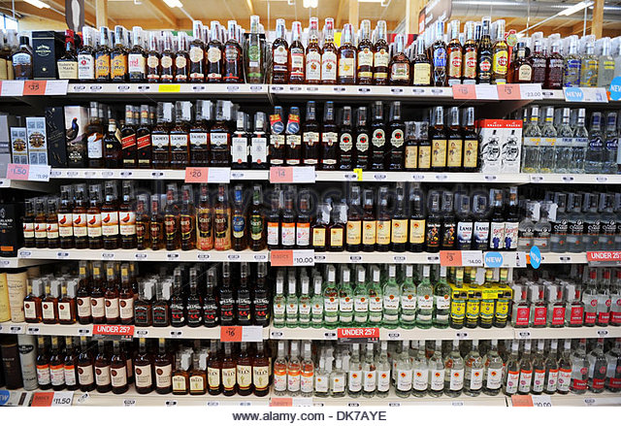
Reducing the availability of alcohol
Reducing alcohol related harm remains a significant challenge in Edinburgh. EADP and the Edinburgh Partnership have raised concerns over the levels of alcohol related harm and the availability of alcohol with the Licensing Forum and the Board. Currently, the Licensing Board has identified one area of overprovision and seven areas of serious special concern in the Licensing Policy Statement. Changes to national legislation have meant that Boards have not been required to review their policy statements in 2016. EADP continues to work with the Licensing Forum to improve members’ understanding of overprovision to help inform licensing policy.
Success Measures
The table below summarises the key data used to identify the success within this stand of the strategy.

Measures | Baseline  2014/15 | Target | Progress | Comment / Source
Reduce alcohol related violent crime and antisocial behaviour
Measures under development
Number of premises selling cheap alcohol
- Not to increase the number of off-sales premises in force per 10,000 population | 14 (2014) | 14 | 14.6 (2014/15) | Scottish Governement Licensing data
      - Financial Framework
This section of the report sets out our financial investment in drug/alcohol services in Edinburgh. Funding for these services comes from a number of sources across the public sector. Edinburgh Alcohol and Drug Partnership brings together NHS Lothian, the City of Edinburgh Council and the Third Sector to ensure that resources are used efficient and effectively to deliver the strategy.

Total Income from all sources – 2015/16

Income | Total
Earmarked funding from Scottish Government 2015/16 | £6,881,808
Carry forward Earmarked funding from Scottish Government 2014/15 | £1,300,000
Funding from Local Authority | £1,391,000
Funding from NHS (excluding funding earmarked from Scottish Government) | £4,038,221
Criminal Justice Funding | £1,811,753
Total | £15,422,782

Total Expenditure from sources – 2015/16

 | Total
Prevention (include community focussed, early years, educational inputs/media, young people, licensing objectives, ABIs) | £963,736
Treatment & Support Services (include interventions focussed around treatment for alcohol and drug dependence) | £12,969,564
Recovery | £756,556
Total | £14,689,856

End Year Balance for Scottish Government earmarked allocations

Funding Stream | Income £ | Expenditure £ | End Year Balance £
Earmarked funding from Scottish Government 2015/16 | £6,881,808
Carry forward Earmarked funding from Scottish Government 2014/15 | £1,300,000
TOTAL | £8,181,808 | £7,448,882 | + £732,926

Total Underspend from all sources

Carry forward | Proposals for future use
£732,926 | Contingency plan established in 2016/17 following Scottish Government decision to reduce the earmarked budget by £1.5 million (22.5%).  The carry forward will be used to maintain existing levels of capacity and quality within treatment and recovery services.

Support in kind

Organisation | Support
Police Scotland | Enforcement activity to disrupt the supply of drugs
Youth Services and Schools | Alcohol and drug education and prevention with young people
Children and Families Social Work, Community Nursing and other Community Support Services in the Public and 3rd Sector | Assessment and intervention to support children and their families where parents use alcohol and drugs.
Adult Social Work, Community Nursing and other Community Support Services | Assessment and intervention to support adults who use alcohol and drugs problematically. This includes those who have mental health problems and alcohol and/or drug problems; those with alcohol related brain injury; those who are homeless.
Primary Care, Accident and Emergency, Hospital, Ambulance and other medical services | Treatment of people whose conditions are related to their alcohol and drug use (e.g. alcohol related accidents, overdose, treatment of blood borne viruses, etc.
Community Safety | Environmental Wardens - safe disposal of needles
Housing | Temporary accommodation and Housing Support for homeless people with substance misuse problems
Appendix 1: Progress against Ministerial Priorities 2015/16
Scottish Government ministers set national priorities for Alcohol and Drug Partnerships, which are reviewed on an annual basis. This section sets out EADP’s response progress against these priorities.

PRIORITY | IMPROVEMENT GOAL 2015-16 | DELIVERY MEASURES and  PROGRESS 2015/16 | Additional Information
Compliance with the Drug and Alcohol Treatment Waiting Times LDP Standard, including, increasing the level of fully identifiable records submitted to the Drug and Alcohol Treatment Waiting Times Database (DATWTD) | 100% data compliance is expected from services delivering tier 3 and 4 drug and alcohol treatment in Scotland.  90% of clients will wait no longer than 3 weeks from referral received to appropriate drug or alcohol treatment that supports their recovery.  No one will wait longer than 6 weeks to receive appropriate treatment | All services have achieved data compliance in 2015/16  Overall in 2015/16 86% of people waited less than 3 weeks to start treatment. 5% waited longer than 6 weeks.  Key actions in 2015/16  - Redesign of model of care to reduce pressure on clinical services including a redesign of the triage, key working arrangements to support people through services and development of a programme of groups and activities to support people to move through services into recovery.  - Remedial plans in place for organisations not delivering to target.
Compliance with the LDP Standard for delivering Alcohol Brief Interventions (ABIs) | No improvement goals have been set in this area.  Edinburgh continues to deliver on a pan Lothian target for the delivery of ABIs | Across Lothian, 28,972 ABIs were delivered within priority settings (GP surgeries, A&E and Maternity settings) against a target of 9,738.  12,179 of these were delivered in priority settings:  - Primary care  - Maternity Services  - A&E  A further 16,793 were delivered in wider settings, including higher education, dentistry, criminal justice, sexual health services, young people’s services, occupational health, amongst others
Increasing Data Compliance SDMD: SMR25 A and B. | Review existing data to ensure organisations are reporting appropriately by October 2015  Collate reports on data accuracy and disseminate to providers on a regular basis  Set remedial plans for organisations to ensure compliance as and when required | All appropriate organisations report SMR A and B data into the database  Reports on data compliance now circulated to providers on a monthly basis  No requirement to individual remedial plans for providers to date.
Preparing Local Systems to Comply with the new Drug & Alcohol Information System (DAISy) | All providers aware of the upcoming DAISy system and involved in Scottish Government/ISD seminars and events as and when required.  Outcome tools reviewed and most effective tool selected to measure outcomes linked to DAISy by 31 March 2016 | All key literature circulated and all providers invited and encouraged to attend key events.  Outcomes Star identified as tool to measure outcomes linked to DAISy. Training to commence in 2016/17.
Increasing the reach and coverage of the national naloxone programme for people at risk of opiate overdose, including those on release from prison. | Ensure naloxone supply is a core part of the service offer within treatment and recovery services and coverage reaches 25% of the PDU estimate  Ensure clear arrangements are in place for the supply of Naloxone to those released from HMP Edinburgh  Identify services working with vulnerable groups and support them to supply Naloxone, including:  - Hostels  - GP surgeries  - Custody suites | Arrangements for the supply of Naloxone in place within treatment and recovery services. 30% of the local estimate for the prevalence of problem drug use is in receipt of Naloxone.  36 people trained to supply Naloxone as a part of treatment service delivery including HMP Edinburgh.  90 hostel and other third sector staff to deliver naloxone to people in an emergency  Naloxone clinic established within one GP surgery.  Arrangements developed and implemented for Naloxone to be supplied from police custody settings.  Protocols are in place in response to the changes in legislation allowing non medical /clinical staff to supply Naloxone, including carers.
Tackling drug related deaths (DRD)/risks in your local ADP. | Ensure that all drug related deaths are reviewed at the appropriate Locality based Drug Related Deaths Group in Edinburgh and key lessons are learned effectively.  Collate key data on drug related deaths and return to the Scottish Government  Produce an annual report setting out the key reasons for drug related deaths to help inform planning.  Continue to produce a drug related deaths action plan based on:  - National priorities  - Local challenges and opportunities identified to drug related deaths data  - Key issues arising through the Drug Related Deaths Review Groups. | Drug Related Death Groups have continued to review all deaths and improve local coordination to reduce deaths.  All data returns made for calendar 2015  Annual report produced for calendar year 2015. Key achievements include:  - Protocol developed with the Ambulance Service to ensure that all those who experience a non fatal overdose receive a proactive follow up response from treatment services. The intention is to ensure they are supplied with naloxone and have access to treatment.  - Briefings for primary care about key risk factors for drug related deaths  - Improved access to support for family members
Implementing improvement methodology including implementation of the Quality Principles: Standard Expectations of Care and Support in Drug and Alcohol Services. | Develop a quality assurance process for treatment and recovery services in line with the Quality Principles.  Each treatment and recovery organisation to undertake a 360 degree review of their service using the domains within the Quality Principles.  All treatment and recovery providers to display information about the quality principles and publicise them with their client group. | Quality assurance process developed and incoming providers of voluntary sector services are fully committed to its implementation  Results are awaited from the Care Inspectorate.
Responding to the recommendations outlined in the independent expert group on opioid replacement therapies. | This section sets out the response to recommendation 1, 2, 6 and 7. Recommendations 3, 4, 5, 8, 9, 10 and 11 are relevant to the Scottish Government and not local planning structures.  Further information on this report is available at http://www.gov.scot/resource/0043/00431023.pdf  Recommendations  - Consideration should be given to the development of mechanisms bringing closer the delivery of approaches to address health inequalities and problem substance use.  EADP Officers to be represented at the newly formed Equalities and Edinburgh’s Equalities and Rights Network  Develop a joint action plan with mental health services in the South East of the city.  - Primary care services – specifically General Practice and Community Pharmacy – are essential elements of the delivery system and should be delivered to national standards.  - Recovery-orientated systems of care (ROSCs) are well described in many guidance documents. All local systems should immediately publish prioritised SMART plans to ensure they can demonstrate a process towards delivery of ROSCs.  - Within the medical and other caring professions, it is everyone’s responsibility to manage drug users and their problems which extend into every clinical speciality. All practitioners can effect change and have opportunities to address drug-related problems within their profession arena. Local systems should have plans in place to ensure substance users are not excluded from generic services. | Primary care is integral to delivery of ORT in Lothians with identified advantages in terms of holistic medical treatment. Developments in 2015-16 include joint reviews of GP’s ORT practice by city wide oversight teams and local specialist teams.  Establishing the full implementation of the quality standards in primary care ORT is complicated by their not being incorporated in the NES contract and a financial context which precludes our increasing obligations on private contractors.  Development of our ROSC this year has included implementation of ARC-E app (which offers up to date information on the wide range of recovery opportunities in the city to the users of all services) and the creation of paid and unpaid peer roles in all of our front line hub services.
Ensuring a proactive and planned approach to responding to the needs of prisoners affected by problem drug and alcohol use and their associated through care arrangements, including women | Implement triage process across NHS Lothian Clinical Services and Lifeline within HMP Edinburgh  Lifeline to link to the Multi-Agency Plan (MAP) to ensure coordination of treatment alongside other support services on release from prison  Pilot a problem solving court approach to those with alcohol related offending (20 people) from February 2016.  Work with the Willow project to develop clear treatment pathway for women within substance misuse problems in contact within the criminal justice system. | Triage process in place, resulting in a significant reduction in inappropriate referrals and waits for service.  Lifeline plays a key role in MAP process to ensure people receive a coordinated response from a range of services.  Treatment pathway developed in partnership with Willow ensuring women in contact with the criminal justice system have access to a range of treatment and recovery options.
Improving identification of, and preventative activities focused on, new psychoactive substances (NPS). | Please see the note on NPS on page 8 and 9 of this report.
On-going Implementation of a Whole Population Approach for alcohol recognising harder to reach groups, supporting a focus on communities where deprivation is greatest. | Work with the Licensing Forum to produce an assessment of overprovision using timeframes set by the Licensing Board for its review of its Policy Statement.  Develop and implement an alcohol prevention pilot in Leith in partnership with Alcohol Focus Scotland.  In partnership with Alcohol Focus Scotland Support the development of national guidance on influencing the licensing process targeted at community groups, residents associations and members of the public. | Assessment of overprovision produced in draft. Key information passed to the Licensing Forum to inform the assessment of overprovision  Action plan produced and implemented in partnership with Leith Neighbourhood Partnership and Alcohol Focus Scotland.  Two consultation events held and national guidance produced in partnership with Alcohol Focus Scotland.
ADP engagement in improvements to reduce alcohol related deaths. | Invest in Social Work alcohol services (alongside drug services) to provide practice outreach to those with alcohol problems, have complex social problems and are unlikely to engage in services  Invest in A&E alcohol liaison service at the Royal Infirmary identifying, signposting and providing a service to those admitted to hospital with alcohol related problems.  Complete test of change to provide step-down unit for people with ARBD, providing earlier discharge from hospital in a recovery oriented environment. | Social Work alcohol service continues to achieve its KPIs for delivery in 2015/16  Alcohol Liaison Service delivering in line with KPIs within the Royal Infirmary identifying those in need of further support and referring them into treatment and recovery services.  Test of change show positive outcomes for those accessing the step-down unit in terms of recovery and use of hospital services.  In 2016/17, EADP plans to work with WLADP and MELDAP and NHSL Health Promotions to:  - Identify issues around alcohol related deaths published data  - Work with ISD to identify the use of health service by people who die from alcohol related deaths  - Identify new opportunities to intervene

Appendix 2: ADDITIONAL INFORMATION 1 APRIL 2015 – 31 MARCH 2016
This section sets out additional information requirements from the Scottish Government in the 2015/16 Annual Report.

1 | Please bullet point any local research that you have commissioned e.g. hidden populations, alcohol related deaths. (the actual research is not required) | - Drug Deaths Annual Report 2014 – summaries key findings from drug death reviews (http://www.drdlothian.org.uk/Data/Pages/default.aspx)
2 | What is the formal arrangement within your ADP for reporting on your Annual Reports/ Delivery Plans/shared documents, through your local accountability route. | The Edinburgh Partnership has identified: Reducing Drug and Alcohol Use as a key priority with Edinburgh’s Community Plan 2015-18. As a result, EADP is identified as a Strategic Partnership delivering on behalf of the Edinburgh Partnership Family.  For further information see: http://www.edinburgh.gov.uk/info/20133/community_planning/391/edinburgh_partnership  EADP reports on progress to the Edinburgh Partnership on an annual basis. During the course of 2015/16 EADP presented two reports to the Edinburgh Partnership Board on addressing alcohol related harm.
3 | A person centered recovery focus has been incorporated into our approach to strategic commissioning.  Please advise if your ROSC is ‘in place’; ‘in development’ or in place and enhancing further.  (No additional information is required) | EADP is currently engaged in further enhancing our recovery oriented system of care (ROSC).
4 | Is there an ADP Workforce Development Strategy in Place, if no, are there plans to develop? | We do not have a separate workforce development strategy. Instead workforce development requirements are set out in our service specifications and contracts with service providers.  Edinburgh IJB is producing a workforce development strategy for the wider workforce and substance misuse treatment and recovery learning will be included within this strategy.  We have developed a stepped care model for psychosocial interventions to support the implementation of the ROSC. This includes key training requirements for those organisations supporting people in their recovery.
5 | A. Please indicate if your ADP has participated in the Drug Death Prevention work of the Scottish Drugs Forum (SDF), as requested by Ministers in their letter to ADP Chairs on 6 August 2014.  B. Please provide details of local Drug Death Prevention strategies in place or planned.  C. Please include details of any local Drug-Related Death groups in place, in addition to the information provided within the Ministerial priorities section. | There is a Pan Lothian Drug Related Deaths Strategic Group, which oversees the development of an action plan to reduce drug related deaths. EADP plays a key role in developing and delivering this action plan.  Four Drug Death Review Groups report to this Strategic Group linked to each of the four Localities in Edinburgh. These are multi-agency groups that carry out a review of every drug death in the local area to understand the reasons behind drug related death and learn lessons for future practice.  The pan Lothian Strategy Group identifies common themes from these groups and through routine data collection to produce an annual report and an annual plan to reduce drug related deaths
6 | Describe the progress your ADP has made in taking forward the recommendations from the Independent Expert Review of Opioid Replacement Therapies (ORT) in Scotland. Please include any information around the following:  - update on progress in implementing your key aim statement – have you achieved it/when do you plan to do so?  - How many people were in receipt of opiate replacement therapies in your area between 1 April 2014 & 31 March 2015.  - Information on length of time on ORT and dose  - Information about any related staff training in ORT provision or recovery orientated systems of care.  - Detail of any ORT focussed groups operating in the area.  - GP engagement – how drug and alcohol treatment is being delivered in primary care settings | - Key Aim Statement  In response to this report, Edinburgh set itself the aim to increase the number of people actively linked to mutual aid (AA / NA / SMART Recovery) and/or the Recovery Community (Serenity Cafe, Sorted, Dry Dock, Branching Out) when ending their treatment. This is now a key success indicator for the partnership. In 2015/16 36 % were linked to the recovery community followed a planned discharge from treatment  - There were 2,742 patients in receipt of ORT through their GP as a part of a National Enhanced Agreement with GPs practices. Alongside this 1,522 were in receipt of ORT within specialist services. This gives a total of 4,264 people within Edinburgh.  - The average dose was by patient for methadone was 72mg per person. Data on average length of time on ORT is not currently available. (Source NHS Lothian)  - In 2015/16, Edinburgh underwent a significant service redesign. This enabled the development of programme of support across the city for people who are stable and ready to move on in their recovery. The responsibility for workforce development activity to deliver these programmes sits with the delivery organisations.  - Edinburgh delivers a range of support around ORT in both group and individual settings within treatment services. This includes: case management, group work programmes, individual psychological therapies, active linkage to mutual aid and the recovery community and wrap around support. These interventions are differently accessible to patients in different treatment settings.  At this time, Edinburgh does not have an ORT and Me mutual aid group running but several of the other groups and networks (most particularly SMART, CA and NA) offer support to those on ORT.  - GPs play a key role within the delivery of drug and alcohol treatment in the city. Approximately - 66% of people are in receipt of ORT through their GP and this is governed through a Local Enhanced Agreement between NHS Lothian and individual GP surgeries. In 2015/16, a significant proportion will have received and alcohol detoxification within primary care.  There is close working between GPs and local treatment and recovery services to ensure that people’s ORT, detox, psychosocial and other recovery needs are met concurrently. This includes the use of a single recovery plan where possible across specialist services and primary which can be accessed by A&E and Out of Hours services as required.

Alcohol Brief Interventions are a structured discussion about alcohol which is evidenced to reduce drinking levels across the population.
It is important to note that within Edinburgh’s Recovery Oriented System of Care it is difficult to distinguish between investments in Treatment and Support Services and Recovery. As a result an estimate of £500,000 has been made for the investment in recovery services post treatment.

