Edinburgh Drug and Alcohol Recovery Hub Drop-ins

The Recovery Hubs are one – stop shops which offer a full range of drug and alcohol treatment and support services. Each is run by a team of staff of voluntary sector, NHS and social work staff.
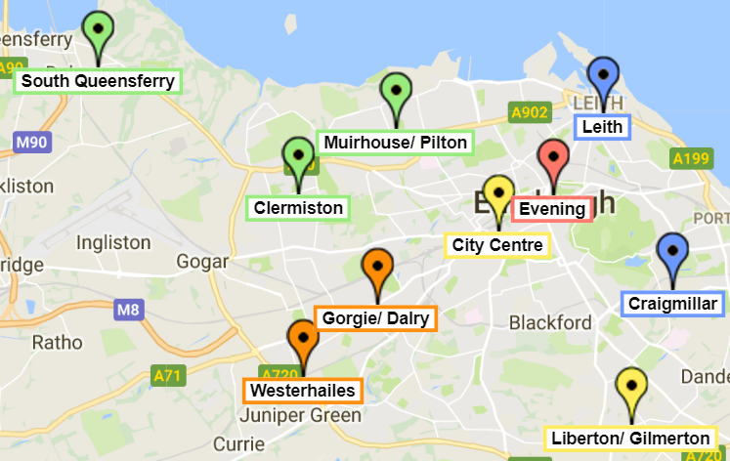
The easiest way for most people to get support from their local Recovery Hub team is to come to a drop-in session. At the Drop-in, the worker will listen, give advice and options, agree a plan and organise the next steps.

All Drop-ins operate a “no wrong door” approach so people can come to any of them regardless of where they live in the city.

People who cannot come to a Drop-in for any reason, or who want more information should contact the hub by phone (see numbers overleaf). They are keen to make it as easy as possible for people to meet them.
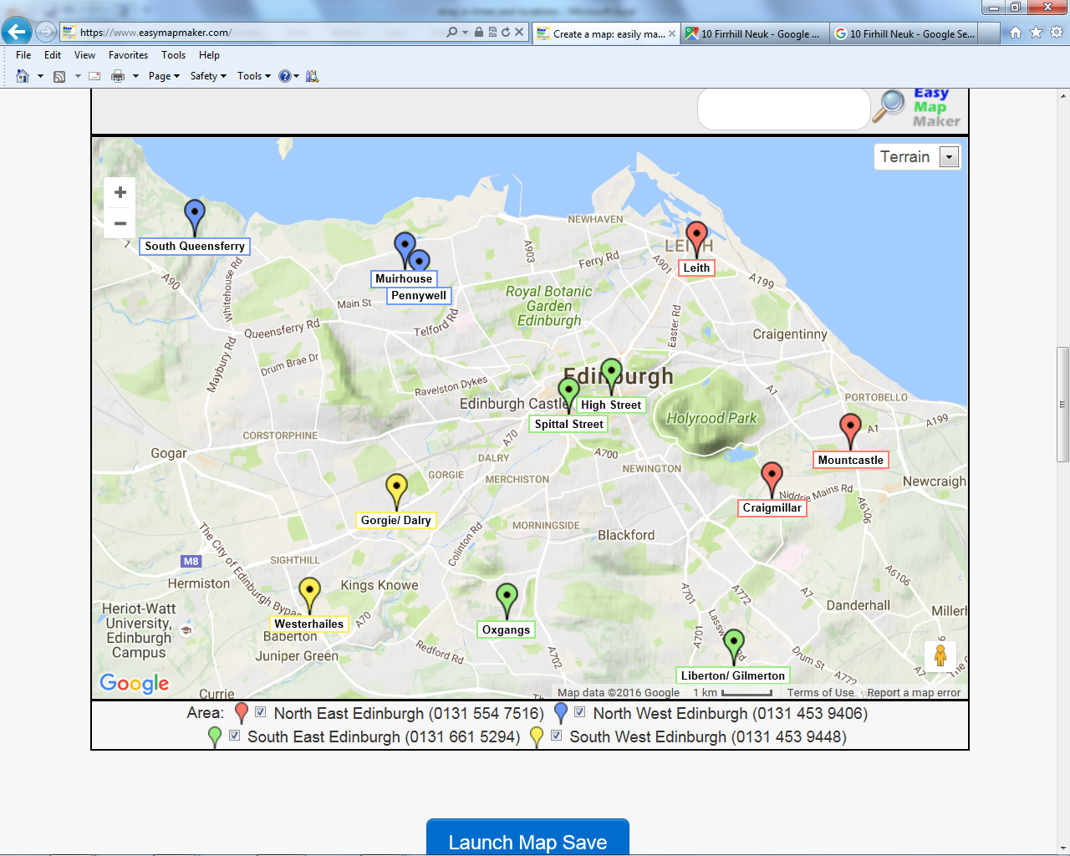North East Edinburgh  (0131 554 7516) | North West Edinburgh  (0131 469 5044)
South West Edinburgh  (0131 453 9406) | South East Edinburgh  (0131 661 5294)

Hub services are confidential and the teams will only share information where they are very concerned that a vulnerable person is being harmed. They offer a choice of male or female workers wherever possible.

For up to date information on all recovery options in Edinburgh, visit www.edinburghadp.co.uk/ Or download the Addiction Recovery Companion – Edinburgh app (www.arcapp.co.uk )

Edinburgh Drug and Alcohol Recovery Hub Drop-ins
Area | Drop in | Location | Monday | Tuesday | Wednesday | Thursday | Friday
North East Edinburgh  (0131 554 7516) | Leith | North East Recovery Hub,  5 Links Place, EH6 7EZ | 1pm – 4pm | 9-11am  4- 7pm  (EVENING) | 1pm – 4pm | 1-4pm | 1pm – 3pm
North East Edinburgh  (0131 554 7516) | Craigmillar | East Neighbourhood Centre,  101 Niddrie Mains Rd, EH16 4DS | 1pm – 4pm |  |  | 1pm – 4pm
North West Edinburgh  (0131 469 5044) | Craigroyston | Craigroyston Health Centre, 1B Pennywell Road, EH4 4PH | 1pm - 4pm | 1pm - 4pm | 9am – 12pm | 1pm - 4pm
North West Edinburgh  (0131 469 5044) | South Queensferry | South Queensferry Medical Practice, 41 The Loan, EH30 9HA |  |  |  |  | 9am -12pm
South West Edinburgh  (0131 453 9406) | Sighthill | Sighthill Medical Centre  380 Calder Rd, Edinburgh EH11 4AU | 1pm -4pm
South West Edinburgh  (0131 453 9406) | Westerhailes | Westerhailes Healthy Living Centre, 32 Harvesters Way, EH14 3JF |  | 1pm- 4pm | 1pm- 4pm | 1pm- 4pm | 1pm-4pm
South East Edinburgh  (0131 661 5294) | Spittal Street | Spittal Street Centre,  22 - 24 Spittal Street, EH3 9DU |  |  | 9am-12pm
South East Edinburgh  (0131 661 5294) | Liberton/ Gilmerton | South Neighbourhood office, 40, Captain's road, EH17 8QF | 1pm-4pm | 1pm-4pm |  | 1pm- 4pm
Evening drop-ins (for people from North West, South West, and South East areas)
City Centre  (0131 557 5273) | City Centre | Change, grow, live office.  62 Broughton Street, Edinburgh EH1 3SA | 4pm -7pm  (EVENING) |  |  | 4pm -7pm  (EVENING)

