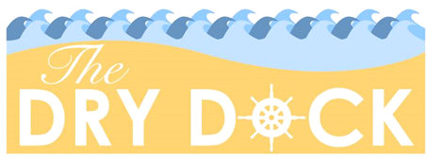

“The Dry Dock is Leith’s first Recovery venue, offering peer support, a safe social space and a variety of activities and classes for the Recovery community and local residents.”

Building Opening Times
Monday – Saturday 12pm – 5pm
Ladies Peer Support Group - Wednesday - 2 – 4pm
Yoga (a small donation is appreciated!) – Thursday – 3.30 – 4.30pm
Coming soon…
SMART Recovery Meetings, Cookery Classes, Drama Group, Safer by Sound Music Group, Acupuncture, Head Massage, Reiki, Day Trips, Tennis, Bowls, Woodwork/Upcycling Class
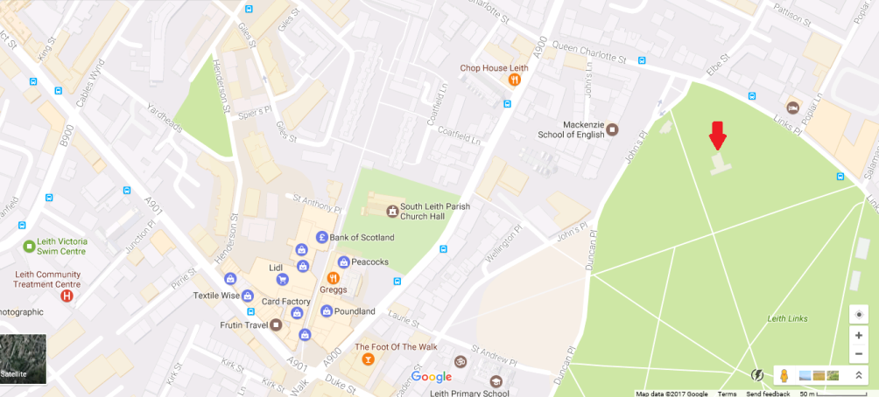
You can find us on Leith Links next to the tennis courts,
at the junction of John’s Place and Links Place

Contact Details
If you have any questions please phone: 07847 625 272
For more information about evening events and new classes and activities follow our Facebook group – ‘The Dry Dock Leith Links’

